Lab 11: Audio/Speech Processing in MATLAB
Objectives:
• Familiarizing students with processing of speech signals in MATLAB.

Lab Tasks:
1. Use MATLAB to read an audio signal, play it, obtain its sampled data, and plot this signal.
CODE:
% Read the audio signal
fs=4410;
[data, fs] = audioread('D:\5th SEM\SNS\lab11 sol\Yokoso Watashi no Soul society.mp3
'); % Replace 'audiofile.wav' with your file name

% Play the audio
sound(data, fs);

% Plot the signal
t = (0:length(data)-1) / fs; % Time vector
plot(t, data);
xlabel('Time (s)');
ylabel('Amplitude');
title('Audio Signal');
grid on;

RESULT:
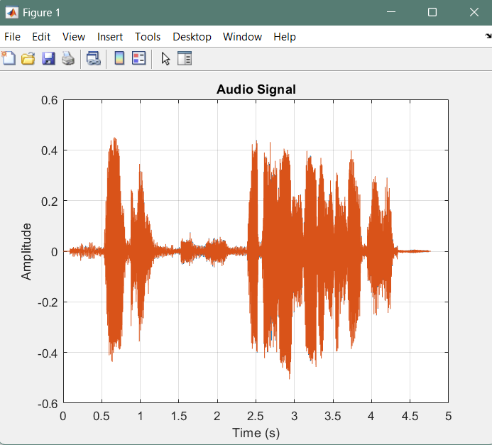
2. Use MATLAB to record a voice signal, play it, obtain its sampled data, and plot this signal.
CODE:
% Record the voice signal
fs = 44100; % Sampling frequency
duration = 5; % Duration in seconds
recObj = audiorecorder(fs, 16, 1); % Create audio recorder

disp('Recording... Speak now.');
recordblocking(recObj, duration); % Record for the specified duration
disp('Recording complete.');

% Play the recorded audio
sound(getaudiodata(recObj), fs);

% Plot the signal
data = getaudiodata(recObj); % Get audio data
t = (0:length(data)-1) / fs; % Time vector
plot(t, data);
xlabel('Time (s)');
ylabel('Amplitude');
title('Recorded Voice Signal');

RESULT:
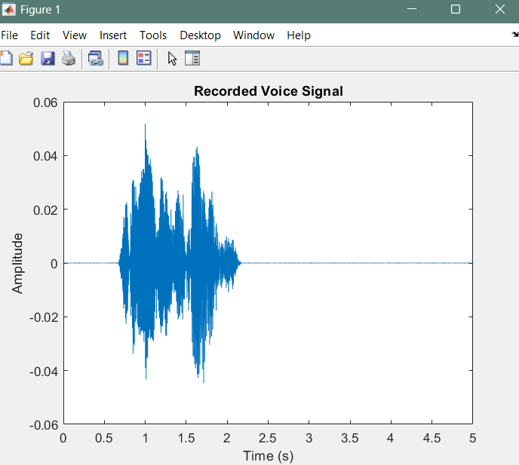
3. Download two test audio files and use MATLAB to obtain the sampled data for these two audio signals. Subtract signal 2 from signal 1. Use subplot command to plot the original signals and the resultant signal.
CODE:
% Step 1: Read the two audio signals
[data1, fs1] = audioread('D:\5th SEM\SNS\lab11 sol\Hisashiburi dana Mugiwara.mp3'); % Replace 'audio1.wav' with your file name
[data2, fs2] = audioread('D:\5th SEM\SNS\lab11 sol\daijoubu desu datte kimi yowai mo gojo Satoru.mp3'); % Replace 'audio2.wav' with your file name
fs1 =44100;
fs2 =44100;
% Check if sampling frequencies match
if fs1 ~= fs2
error('Sampling frequencies of the two audio files do not match.');
end

% Ensure both signals have the same length
minLength = min(length(data1), length(data2));
data1 = data1(1:minLength, :); % Truncate to the shortest length
data2 = data2(1:minLength, :); % Truncate to the shortest length

% Step 2: Subtract signal 2 from signal 1
resultantSignal = data1 - data2;

% Step 3: Plot the signals
t = (0:minLength-1) / fs1; % Time vector

figure;

% Plot Signal 1
subplot(3, 1, 1);
plot(t, data1,'g');
xlabel('Time (s)');
ylabel('Amplitude');
title('Signal 1');
grid on;

% Plot Signal 2
subplot(3, 1, 2);
plot(t, data2);
xlabel('Time (s)');
ylabel('Amplitude');
title('Signal 2');
grid on;

% Plot Resultant Signal
subplot(3, 1, 3);
plot(t, resultantSignal,'y');
xlabel('Time (s)');
ylabel('Amplitude');
title('Resultant Signal (Signal 1 - Signal 2)');
grid on;

RESULT:
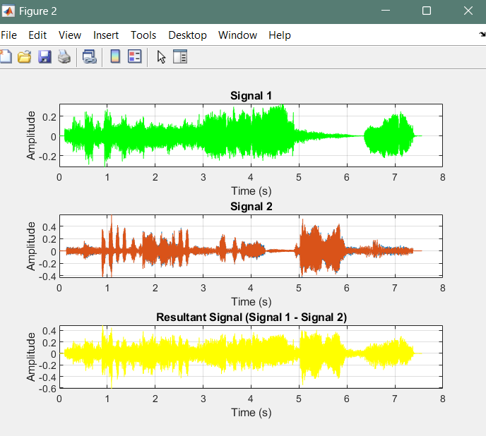

4. Download two test audio files and use MATLAB to concatenate the first file with the second file.
Use subplot command to plot the original signals and the resultant signal.
(Hint: The order of concatenation should be such that the resultant signal should have signal 1 first
and signal 2 right after signal 1.)
CODE:
% Step 1: Read the two audio signals
fs1 = 44100;
fs2 = 44100;
[data1, fs1] = audioread('D:\5th SEM\SNS\lab11 sol\Hisashiburi dana Mugiwara.mp3'); % Replace with your first audio file
[data2, fs2] = audioread('D:\5th SEM\SNS\lab11 sol\Ore Wa Kaizoku-ou Ni Naru Otoko.mp3'); % Replace with your second audio file

% Step 2: Check if sampling frequencies match
if fs1 ~= fs2
error('Sampling frequencies of the two audio files do not match.');
end

% Step 3: Concatenate the signals
resultantSignal = [data1; data2];

% Step 4: Create time vectors
t1 = (0:length(data1)-1) / fs1; % Time vector for Signal 1
t2 = (0:length(data2)-1) / fs2; % Time vector for Signal 2
tResult = (0:length(resultantSignal)-1) / fs1; % Time vector for the resultant signal

% Step 5: Plot the signals
figure;

% Plot Signal 1
subplot(3, 1, 1);
plot(t1, data1);
xlabel('Time (s)');
ylabel('Amplitude');
title('Signal 1');
grid on;

% Plot Signal 2
subplot(3, 1, 2);
plot(t2, data2);
xlabel('Time (s)');
ylabel('Amplitude');
title('Signal 2');
grid on;

% Plot Resultant Signal
subplot(3, 1, 3);
plot(tResult, resultantSignal);
xlabel('Time (s)');
ylabel('Amplitude');
title('Concatenated Signal (Signal 1 followed by Signal 2)');
grid on;
sound(resultantSignal, fs1);

RESULTS
